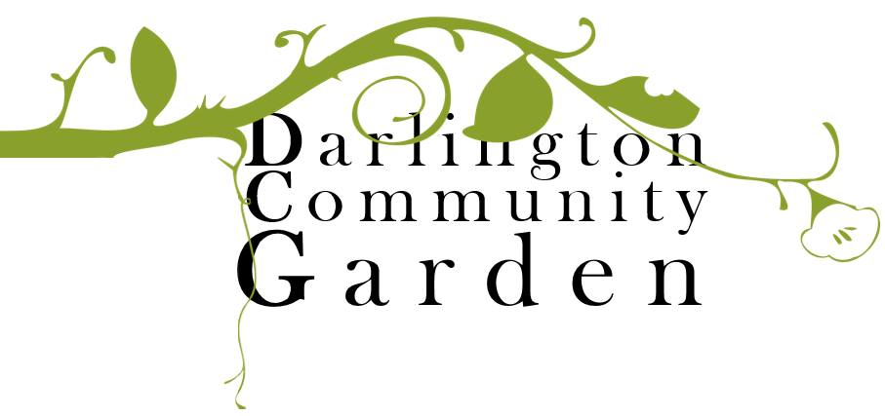

Membership Form

Join us to get the Darlington Community Garden ‘germinating’. We can’t grow without you!
Be a part of the growth of the DCG. Membership covers insurance costs and allows you to be part of the decision making.

Full name:

Additional
family
members:
Address:

Email:

Mobile no.:

How would | you like to be involved with DCG?

Annual membership runs from 1 July to 30 June.

Membership type | Number of memberships | Subtotal
Adult ($20 each)
Unwaged Adult ($15 each)
Child
Pay forward membership
 | Total

Payment method: Card Cash

Direct Deposit: BSB: 633 000 Account : 168 723 849

If payment of the membership fee will prohibit you from becoming a member, please contact Memberships officer Natalie Balgera darlingtoncg@hotmail.com for confidential chat to discuss further options.

