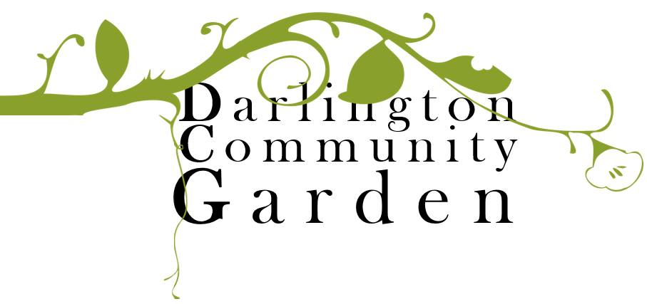

Membership Form

Join the Darlington Community Garden. Be a part of the growth of the DCG. We can’t grow without you! Membership covers insurance costs and allows you to be part of the decision making process for our community garden.

Full name:

Additional
family
members:
Address:

Email:

Mobile no.:

How would | you like to be involved with DCG?

Annual membership runs from 1 July to 30 June.

Membership type | Number of memberships | Subtotal
Adult ($20 each)
Unwaged Adult ($15 each)
Child
Pay forward membership
 | Total

Payment method: Card Cash

Direct Deposit: BSB: 633 000 Account : 168 723 849

If payment of the membership fee will prohibit you from becoming a member, please email darlingtoncg@hotmail.com to request a ‘pay it forward’ membership (no questions asked).

